POP TEE
Meeting table
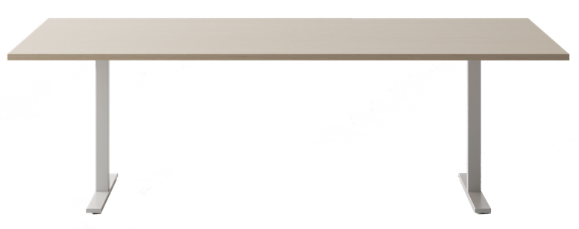

TECHNICAL DATA
structure with 2 legs for vertical cable  management and cable beam |  | leg for cable access: consisting of a square-section vertical upright (W. 2” 3/8 D. 2” 3/8) in 1.5 mm thick steel sheet, welded to a 2 mm thick steel sheet base (W. 27” 1/2 D. 2” 3/4 H. 3/4”) with 1.5 mm thick ABS end caps. Under the base there are two adjusting feet that allow +10 mm excursion for levelling. On the inside of the upright there are 2 holes (1 upper Ø 1” 3/4, 1 lower rectangular 1” 3/4 x 2” 1/2) to allow the cables to be lowered to the ground. A 4 mm thick steel plate (W. 18” 1/2 D. 2” 3/8) is welded to the upper part of the upright with loops for fixing it to the top. All metal parts are epoxy powder coated with an embossed finish..
 |  | cable beam: made of a 1.2 mm thick steel sheet (L. variable W. D. 2” 3/8 H. 2” 5/8), bent to create an inspectionable tray for cable routing, fixed and secured with screws on the inner part of the leg. It features four Ø 1” 3/4 holes, two of which are positioned at the ends to allow cables to pass down through the leg to the floor. All metal parts are epoxy powder coated with an embossed finish.
structure with 2 columns  and square base |  | column: made from a square-section steel tube (W. 3” 1/8 D. 3” 1/8) made from 2 mm thick steel sheet with rounded edges. A 4 mm thick steel plate (W. 12” 1/4 D. 12” 1/4) is welded to the top of the column and is provided with loops for fixing to the top. The column is epoxy powder-coated. The height of the column is 27” 3/8.
 |  | base: made of 8 mm thick steel sheet (W. 22” 7/8 D. 22” 7/8) and fitted with 4 adjusting feet that allow +10 mm for levelling.
structure with 2 columns  and round base |  | column: consisting of a circular tube (Ø 4” 3/4) made of 2 mm thick steel sheet. A 4 mm thick steel plate (Ø 16” 1/8) is welded to the top of the column and is provided with loops for fixing to the top. The column is epoxy powder-coated. The height of the column is 27” 1/2.
 |  | base: made of 8 mm thick steel sheet (Ø 23” 5/8) and equipped with 6 adjusting feet that allow +10 mm adjustment for levelling.
top |  | melamine: 25 mm thick chipboard (density 720 kg/m³, formaldehyde emission compliant with EU Regulation 2023/1464 and EPA TSCA Title VI), faced with anti-reflex melamine resins and edged with ABS (2 mm th. with rounded edges) The desk top is provided with bolts and it is connected to the metal structure through screws.  Top height from the floor: 29”1/2.
table with rectangular top dimensions
  W | D | H
  82”5/8 | 39”3/8 | 29”1/2
table with oval top dimensions
  W | D | H
  70”7/8 | 35”3/8 | 29”1/2
  82”5/8 | 39”3/8 | 29”1/2
leg and beam finish | metal
   | ZGBI White embossed painted RAL 9010 |  | ZGAS Aluminium embossed painted  RAL 9006 |  | ZGNE Black embossed painted  RAL 9005
top finish | melamine
   | MBI White |  | MWP Pearl white |  | MTR Dove
   | MCE Concrete |  | MOB Light elm |  | MRO Oak
      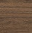 | MNC Walnut |  | MFN Black ash |  | MNV Black velvet
OPTIONALS
1. top access |  | metal: consisting of a base frame made of two anodised or epoxy powder-coated extruded aluminium profiles and two ABS closing elements. The upper part comprises an extruded or painted aluminium door mounted on two ABS hinges that allow it to be opened on both sides in a mutually exclusive manner. On both sides there is a dust cover profile. The top access door can swing in either direction by rotating on two pivots fitted inside the frame.  W. 12” 1/2 D. 5” 7/8 H. 1”
2. cable tray for top  access |  | made of 1 mm thick, U-shaped, epoxy powder-coated steel sheet. The tray interlocks with the top access frame and is fitted with holes on the lower side that can be used for attaching multiple-plug sockets (by means of screws or clamps, not included) or for earthing (by screwing the cable lug for earthing with screw and bolt, not included). W. 11” 3/8 D. 4” 7/8 H. 3” 7/8.

ABACUS | Meeting tables
Structure with 2 legs for vertical cable
management and cable beam
Rectangular top | Oval top
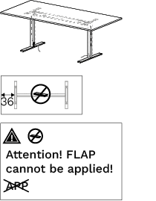 | 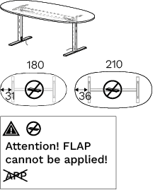
Structure with 2 columns  and square base | Structure with 2 columns  and round base | Structure with 2 columns  and round base
Rectangular top | Rectangular top | Oval top
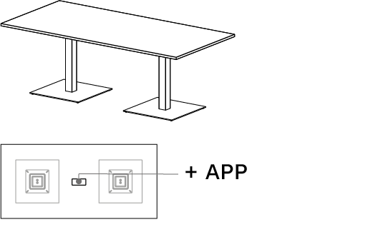 | 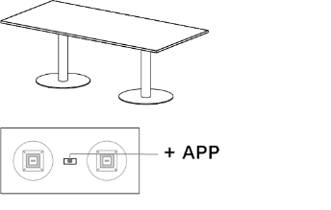 | 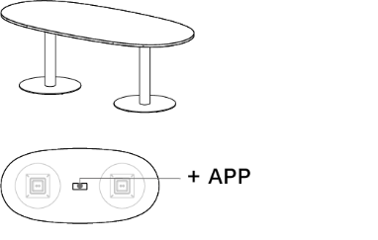

ABACUS | OPTIONALS
1. top access | 2. cable duct for top access
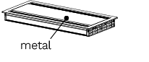 | 