POP FOLDING

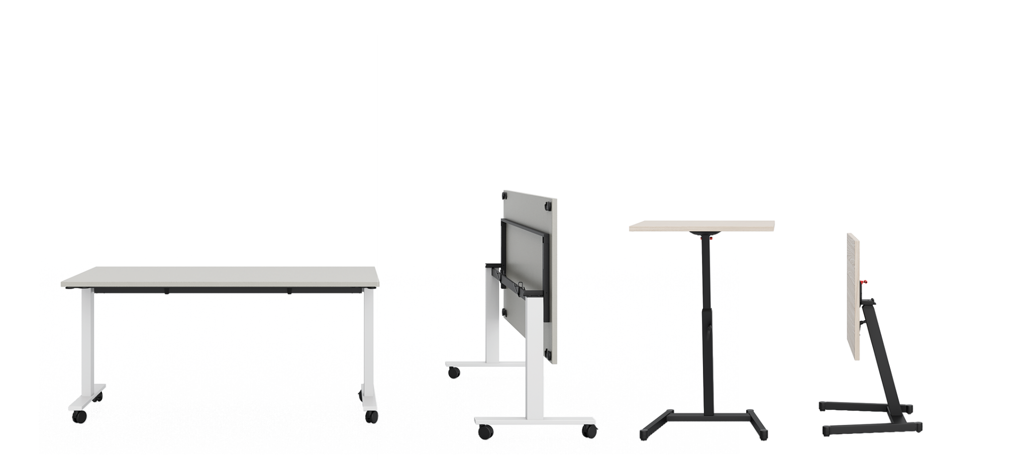Height-adjustable gas lift table

|  |  |
| --- | --- |
| TECHNICAL DATA | |
| structure | consisting of a central upright with a rectangular section (60x50 mm), inside which slides another upright with a square section (40x40 mm) allowing it to be raised in height. A lever is placed on the main upright in order to lock the desk top at the desired height. The main upright is fixed to a base consisting of a crosspiece made from a 2 mm thick steel tube with a 70x30 mm rectangular section, connected to two lateral tubes with a 40x30 mm section (2 mm thick). Each tube is equipped with an adjustable foot with a diameter of Ø 30 mm that allows a 10 mm excursion for levelling, and a recessed castor with a diameter of Ø 28 mm for easy movement. The base has an overall size of W. 25” 1/4 x D. 20” 3/8. |
| height-adjustment: by means of a gas spring which allows a maximum excursion of 15” (H. min 27”3/8 - H. max 42”3/8) |
| top | melamine: 25 mm thick chipboard (density 720 kg/m3, formaldehyde emission class E1, meets CARB requirements), faced with anti-reflex melamine resins and edged with ABS (2 mm th. with rounded edges). The top is equipped with threaded inserts for the attachment of an adapter, which is then fastened to the structure by means of metric screws. The adapter is equipped with a lever that allows the top to be unlocked and tilted by 90°. The top has dimensions W. 27”1/2 and D. 23”5/8 |
| desk dimensions (in cm) | |  |  |  | | --- | --- | --- | | W | D | H | | 27”1/2 | 23”5/8 | 27”3/8÷42”3/8 | |
| leg and beam finish | metal   |  |  |  |  |  |  | | --- | --- | --- | --- | --- | --- | |  | BG White  RAL 9016 |  | NE Black  RAL 9005 |  |  | |
| top finish | melamine   |  |  |  |  |  |  | | --- | --- | --- | --- | --- | --- | |  | MBI White |  | MWP Pearl white |  | MTR Dove | |  | MCE Concrete |  | MOB Light elm |  | MRO Oak | |  | MNC Walnut |  | MFN Black ash |  | MNV Black velvet | |

ABACUS | Table

|  |  |  |
| --- | --- | --- |
| Height-adjustable table |  |  |
| Table with tilting top –  2 castors without break |  |  |
|  |  |  |