POP FOLDING
Desk with tilting top

TECHNICAL DATA
structure | metal legs: made of two 1.5 mm th. steel tubes with a rectangular section (80x50 mm), each of which is fixed to a 2 mm th. steel tube base measuring W. 2” 3/4 D. 26” 1/2 H. 3/4”. Two castors with a Ø 2”1/5 diameter are fixed to the base, one of which is equipped with a brake. All metal parts are epoxy powder coated with an embossed finish.
 | cable beam: made of a 1.2 mm thick steel sheet (L. variable W. D. 23” 5/8 H. 26” 3/8), bent to create an inspectionable tray for cable passage, fixed and secured with screws to the inner side of the leg. Four holes (Ø 45 mm) are also provided, two of which are positioned at the extremities to allow the cables to be routed down through the leg.
 | desk top tilting system: made with a device featuring a locking and unlocking position. This system is made of a 2 mm thick steel plate, and is fixed to the leg which is equipped with a pivot that allows the top to rotate 90°.
top | melamine: 25 mm thick chipboard (density 720 kg/m³, formaldehyde emission class E1, meets CARB requirements), faced with anti-reflex melamine resins and edged with ABS (2 mm th. with rounded edges). The top is equipped with threaded inserts for attachment to the structure and it is fixed to the legs with metric screws. Under the top, in each corner, there are two hooks for connecting the tables to each other. Two of them are fixed pivot, while the other 2 are clips that close around the pivot to fasten the tops together.
table connecting system | under the top, in each corner, there are two hooks for connecting the tables to each other. Two of them are fixed pivot, while the other 2 are clips that close around the pivot to fasten the tops together.
modesty panel | melamine: 18 mm thick chipboard (density 720 kg/m³, formaldehyde emission class E1, meets CARB requirements), faced with anti-reflex melamine resins and edged with ABS (2 mm th. with rounded edges). The modesty panel is fixed by means of hinges located under the desk top in order to maintain its perpendicularity even when the desk top is tilted.
table dimensions (in cm) | rectangular top  W D H W D H  47”1/4 31”1/2 29”1/2 47”1/4 23”5/8 29”1/2  55”1/8 31”1/2 29”1/2 55”1/8 23”5/8 29”1/2  63” 31”1/2 29”1/2 63” 23”5/8 29”1/2  70”7/8 31”1/2 29”1/2 70”7/8 23”5/8 29”1/2
top with meeting area |  |  |  | trapezoidal top
W | D | H |  | W | D | H
47”1/4 | 31”1/2 | 29”1/2 |  | 63” | 31”1/2 | 29”1/2
55”1/8 | 31”1/2 | 29”1/2
63” | 31”1/2 | 29”1/2
70”7/8 | 31”1/2 | 29”1/2

pentagonal top |  |  |  | semi-circular top
W | D | H |  | W | D | H
79”1/8 | 39”3/4 | 29”1/2 |  | 89” | 40”1/2 | 29”1/2

structure finish | metal legs  ZGBI White embossed painted RAL 9010 ZGAS Aluminium embossed painted RAL 9006 ZGNE Black embossed painted RAL 9005
metal beam
NE Black
RAL 9005

top finish | melamine  MBI White MWP Pearl White MTR Dove  MCE Concrete MOB Light elm MRO Oak  MNC Walnut MFN Black ash MNV Black velvet
OPTIONALS
1. modesty panel | melamine: 18 mm thick chipboard (density 720 kg/m³, formaldehyde emission class E1, meets CARB requirements), faced with anti-reflex melamine resins and edged with ABS (2 mm th. with rounded edges). The modesty panel is supported by two plastic brackets. The brackets are fixed by means of metric screws to the lower side of the top and on the sides of the modesty panel, both of which have holes with threaded inserts.  W. 31”1/2 / 39”3/8 / 47”1/4 / 55”1/8 D. 3/4” H. 11”3/4

ABACUS | Tables
Table with rectangular tilting top | Table with meeting area and tilting  top | Table with trapezoidal-shaped tilting top
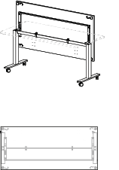 | 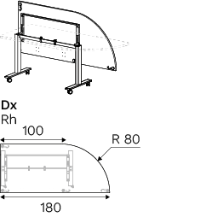 | 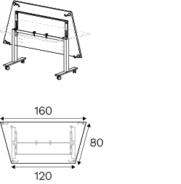
Table with pentagonal-shaped tilting  top | Table with semi-circular tilting  top
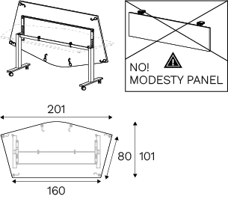 | 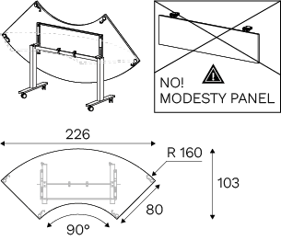

ABACUS | Optionals
1. modesty panel
